HW1

BSEN 7110 –INSTRUMENTATION FOR BIOLOGICAL SYSTEMS ENGINEERS

LABVIEW REPORT

JASKARAN DHIMAN

(jzd0028)

Instructor: Pengmin Pan 10/7/12

Dr. Timothy McDonald

**(a)**

Random number function was used to generate random values. As is generates positive numbers only between 0 and 1, output was multiplied with 2 and then 1 was subtracted from the result. This way numbers between -1 and 1 could be generated. A numeric indicator was used to display these values

**(b)**

The structure was placed within a while loop and a “wait” function was put in the loop. A constant for 500ms was created for the timing delay.

**(c)**

Wavechart function was used to plot a graph/chart of the received values against the time axis. X and Y scales were set on “autoscale” option.

**(d)**

A case structure was built within the while loop whose case selector mode/switch was controlled by the positive outputs only from our received values. This means that whenever a positive number would be generated, the case selector would select the “true” case to work in the case structure, otherwise false. A numeric indicator is set within the true case to show the positive values. These positive values are connected to build array function which then converts it to string using string from array function. Output from this string from array function is given to a write text file function as input. We convert the array to string as only string could write a .txt file. This write text file is given input from open/create file operation function placed outside the while loop. The output from the text file is given to close file operation function too placed outside the while loop (refnum and error). In false case, we simply connect the relevant wires without any modification.

The program is required to terminate itself after first 10 positive values have been registered. A shift register is required to execute the abovesaid and we add a shift register on the while loop. We connect the shift register symbols on left and right side of the loop together through the case structure. In the true case we increment the value by 1 (in the connection) and in false case we don’t do any modification. We use comparison “=” function as the shift register wire comes out of case structure to stop the program once 10 true cases have been passed, or “10 positive values have been received”.

**(e)**

To count the number of loops in total executed to get these 10 positive values, we use a numeric indicator and wire it to the “I” symbol (iteration) at the bottom left of the loop.

In the next pages, screenshots to illustrate the program are given. The first screenshot is the block diagram and the second one is the front panel.

(text file with first 10 positive values recorded during first run of the program is sent separately)

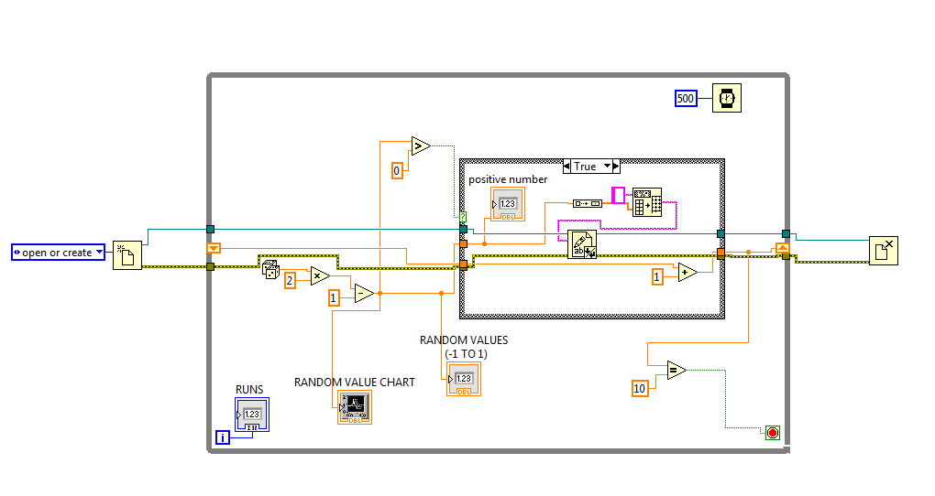

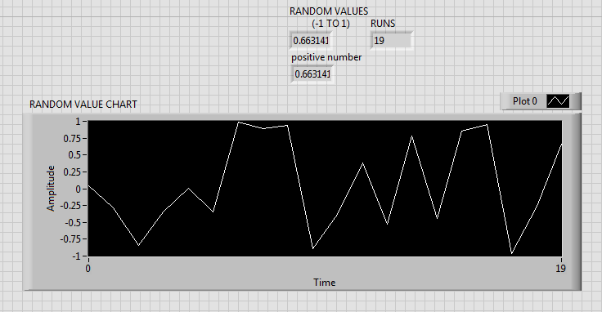

ACKNOWLWDGEMENT

* Dr. Timothy McDonald and Pengmin Pan for introducing and instructing the software to the class.
* Labview “Getting Started Tutorial” in Labview help itself.
* National Instruments video tutorials on youtube.